# Random Walker

## 组装

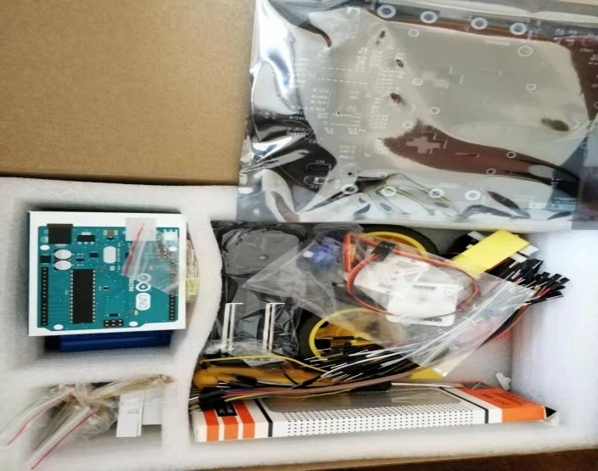 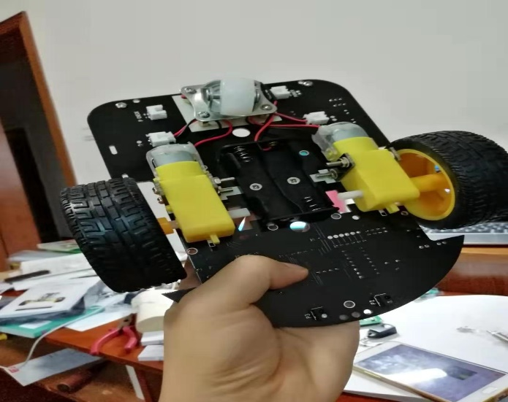

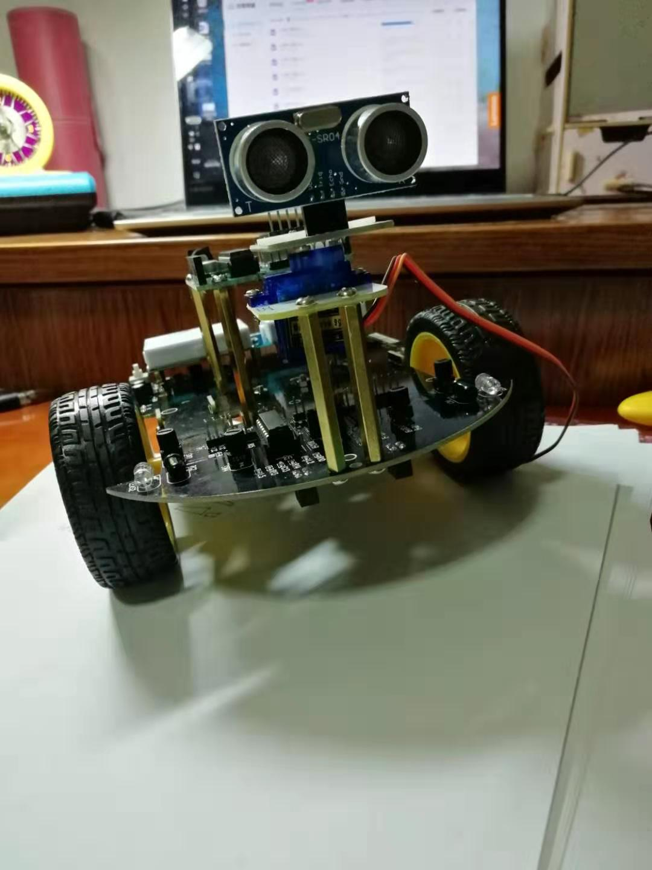

## 控制

**单边电机控制函数：**

void unilateralControl(int side, int back, int go, int velocity, int time) { //单边电机控制：前进/后退/停转

if (back && go) return; //据说这样会烧毁电机

int backwards, forwards;

//assert：side是输入无误的

side == left ? ( backwards = Left_motor_backwards, forwards = Left_motor_forwards ) :

( backwards = Right_motor_backwards, forwards = Right_motor_forwards );

digitalWrite(backwards, back ? HIGH : LOW);

digitalWrite(forwards, go ? HIGH : LOW);

//PWM比例0~255可调速

analogWrite(backwards, back ? velocity : 0);

analogWrite(forwards, go ? velocity : 0);

delay(time);

}

通过对左右电机的控制可以实现小车的多种运动（前进run，制动brake，左右转向turn_left, turn_right，CCW/CW自旋spin_left, spin_right）

**演示视频：（双击打开）**

